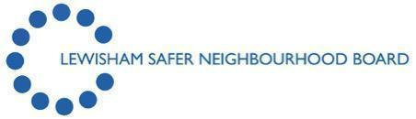

Hate Crime Working Group

MINUTES

Venue: Meeting to be held via Microsoft Teams
Date: 6th March 2026
Time: 1.00pm – 3.00pm

1) | Chair’s Welcome and Introductions and Minutes Agreed  Acknowledged
  Attendees
  Sharon Kilborne | Chair/SNB | SK
  John Au | Stop Hate UK | JA1
  James Mitchell | SNB/IAG Chair | JM
  Lynda Roberts | Thames Reach | LR
  Andre Blackman | Apax | AB
  Simon Holifield | Fairway Lodge Manager | SH
  Phil Turner | Community Development Worker, Second Wave | PT
  Gavin Durnell | Met Police | GD
  Cherelle Reid | Community Engagement Officer, Safer Communities, Lewisham Council | CR
  Rosemarie Ramsey | SNB | RR
  Joy Alert-Doran | Single Homelessness Housing Project (SHIP) | JAD
  Adel | Volunteer 172430 | A
  Jacob Walsh | Joint Commissioner, Adult Integrated Commissioning Team | JW
  Apologies received
2) | Statistics (Council, Police, Stop Hate UK)  Cherelle shared the below statistics in Karen’s absence.  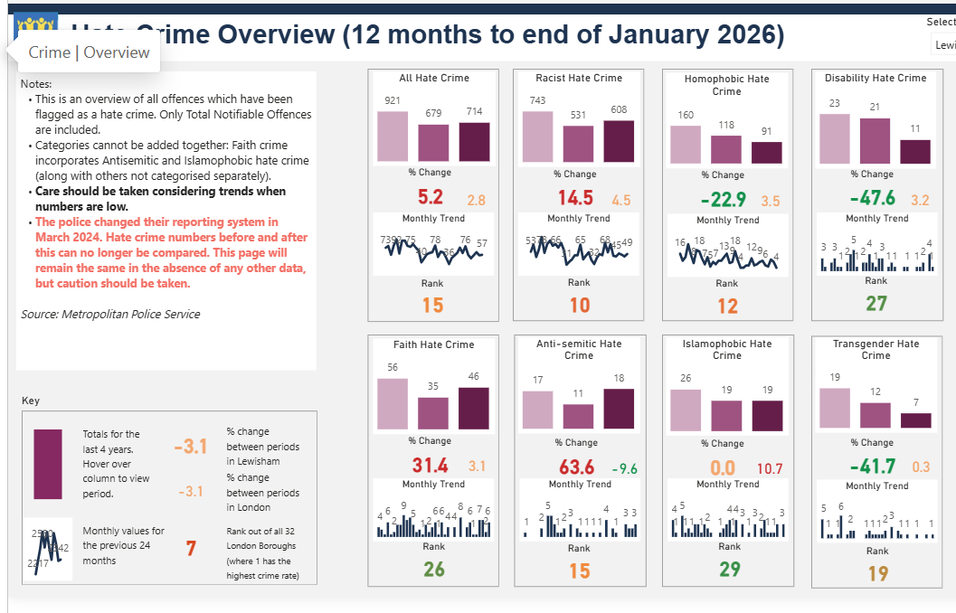  CR advised the group to send any queries relating to the above directly to her, and she will share them with Karen, who is best placed to respond.  Discussions took place regarding the rise in antisemitic and faith hate crime. It was suggested that when there are noticeable spikes affecting specific groups, representatives should be invited to share how their communities have been impacted and what support may be needed.  CR confirmed that members of the Inter Faith Forum have been invited, but due to current capacity they are unable to attend.  SK noted that work is underway to ensure a diverse range of representatives are able to attend future meetings.
3) | An update from the Council  CR confirmed that the Safer Communities Service will be supporting Stop Hate UK to refresh their service delivery, with this work aligned to National Hate Crime Awareness Week.
4) | An update from the Police  GD stated that although overall reporting remains on a steady decline locally, the incidents that are reported tend to reflect wider global tensions. Only one significant spike in hate crime has been identified recently, occurring on either 16 or 18 February where there were 8 incidents reported in one day. An update was provided regarding the synagogue in Catford, where there is a strong and positive relationship with attendees and with the security team. Officers visit regularly and ongoing liaison has been maintained with Karen the former Faith Liaison Officer. Karen reported that she had spoken with the synagogue earlier in the week and she attended for a couple of days last week. No issues have been reported directly by the synagogue. However, this does not rule out concerns arising elsewhere in the borough. It was noted that Lewisham is not typically known for high levels of this type of incident.  SK along with anyone from the HCWG stated she would like to attend the Synagogue with GD to show support, solidarity and look at what more needs to be done. SK suggested a interfaith event outside of the Interfaith walk.  AB stated that he will Look into how APAX can support in terms of the solidarity element.  GD Shared the following Presentation.  Summary – Hate Crime Overview  Period: 01 January 2026 – 03 March 2026  Headline Position  - 102 hate crime offences recorded in Connect and tagged as hate crime.  - The majority relate to racial or racial/religious hostility.  - Peak daily volume: 6 offences on 18 February 2026.  Current Year-to-Date Breakdown (01 Jan – 03 Mar 2026)  Some offences may have one or more flag added  Key Point: Racially or religiously aggravated offences dominate the demand profile, consistent with borough trends across the last 12 months.  Victim & Suspect Profile – Last 3 Months (1 Jan–3 Mar 2026)  Victim Profile (97 recorded)  Gender (counts)  - 63.2% male | 36.8% female  Ethnicity  - Black 39.2% (38) | White 27.8% (27) | Asian 19.6% (19) | Other 2.1% (2) | Unknown 11.3% (11)  Key insights (3-month snapshot)  - Male-dominant victimisation continues (2:1), consistent with hate-crime patterns.  - Black is the largest counted victim group, with Asian share notably high for the quarter (19.6%).  - Unknown ethnicity is relatively low (11.3%) for the quarter—better recording than the 12-month baseline.  Suspect Profile (68 recorded)  Gender (counts)  - 66.2% male | 29.4% female | 4.4% unknown  Ethnicity  - White 42.6% (29) | Black 32.4% (22) | Asian 4.4% (3) | Other 2.9% (2) | Unknown 17.6% (12)  Key Insights  - Suspects are also predominantly male, which aligns with national hate-crime offending trends.  - White suspects represent the largest category (29), followed by Black suspects (22).  - The 12 unknown ethnicity suspects signal opportunities for improved data quality at first contact / during investigative updates.  12-Month Demand Summary (Rolling) 03/03/2025 – 03/03/2026  Some offences may have one or more flag added  Key Observations:  - Racial and racial/religious offences account for 85–90% of total hate crime.  - Homophobic and religious incidents (non-specific) form the next highest bands.  - Transphobic and disability-related offences remain low but are high-impact and require enhanced safeguarding.  Victim Profile (680 in last 12 months)  Gender (counts)  - 67% male | 33% female  Ethnicity  - Black 35.4% (241) | White 26.3% (179) | Asian 14.3% (97) | Other 1.6% (11) | Unknown 22.4% (152)  Insight: Clear male majority across the year. Black and White are the two largest victim groups. Unknown is high (22.4%), constraining disproportionality analysis and ward-level targeting.  Suspect Profile (525 in last 12 months)  Gender (counts)  - 65.7% male | 31.4% female | 2.9% unknown  Ethnicity  - White 46.1% (242) | Black 29.7% (156) | Asian 5.7% (30) | Other 2.3% (12) | Unknown 15.6% (82)  Insight: Hate-crime suspect profile is two-thirds male, stable over time. Ethnicity distribution is broad, with a large White cohort (46%) and Black cohort (30%); however, 16% Unknown limits precision.  12-Month Demand Summary (Rolling) 03/03/2025 – 03/03/2026  Some offences may have one or more flag added  Key Observations:  - Racial and racial/religious offences account for 85–90% of total hate crime.  - Homophobic and religious incidents (non-specific) form the next highest bands.  - Transphobic and disability-related offences remain low but are high-impact and require enhanced safeguarding.  Victim Profile (680 in last 12 months)  Gender (counts)  - 67% male | 33% female  Ethnicity  - Black 35.4% (241) | White 26.3% (179) | Asian 14.3% (97) | Other 1.6% (11) | Unknown 22.4% (152)  Insight: Clear male majority across the year. Black and White are the two largest victim groups. Unknown is high (22.4%), constraining disproportionality analysis and ward-level targeting.  Suspect Profile (525 in last 12 months)  Gender (counts)  - 65.7% male | 31.4% female | 2.9% unknown  Ethnicity  - White 46.1% (242) | Black 29.7% (156) | Asian 5.7% (30) | Other 2.3% (12) | Unknown 15.6% (82)  Insight: Hate-crime suspect profile is two-thirds male, stable over time. Ethnicity distribution is broad, with a large White cohort (46%) and Black cohort (30%); however, 16% Unknown limits precision.  Overall Assessment  - Hate crime in Lewisham remains predominantly racial in nature, with a consistent pattern across both short-term and long-term data.  - Victim profiles indicate disproportionality impacting minority communities.  - The volume of named suspects provides opportunities for targeted interventions, repeat offender management and partnership-led problem solving.  - February showed a noticeable spike (peak of 6 on 18 Feb), which may warrant additional context or locality analysis.  The peak of 6 hate crimes on 18 February is most plausibly associated with:  - Escalating Middle East military conflict (major strikes and retaliations).  - Increased US–Iran nuclear tensions and associated media attention mid–late Feb.  - Wider global conflicts and protest activity creating a heightened climate of international tension.  These events directly align with the types of offences that recorded increases (racial, racial/religious, Islamophobic, anti-Semitic).  Looking forward to the next 12 months if this standard of reporting continues, we are likely to see a decrease on current run rate.  Caveats to note:  - This is a short window (Jan–early Mar) and may be affected by seasonality and single-day spikes.  - Operational activity and international events later in the year could shift the trajectory.
  102 hate crime offences recorded Hate Crime Type | Volume
  Anti-Semitic | 4
  Disability | 1
  Homophobic | 12
  Islamophobic | 5
  Racial | 85
  Racial/Religious | 93
  Religious (non-specific) | 10
  Transphobic | 2
  A total of 714 hate crime offences recorded in the past 12 months: Hate Crime Type | Volume
  Anti-Semitic | 18
  Disability | 11
  Homophobic | 94
  Islamophobic | 20
  Racial | 606
  Racial/Religious | 636
  Religious (non-specific) | 46
  Transphobic | 5
  A total of 714 hate crime offences recorded in the past 12 months: Hate Crime Type | Volume
  Anti-Semitic | 18
  Disability | 11
  Homophobic | 94
  Islamophobic | 20
  Racial | 606
  Racial/Religious | 636
  Religious (non-specific) | 46
  Transphobic | 5
5) | Update from community and group members  JA1 Stated that Stop Hate UK (SHUK) are working on refreshing their service delivery with Partners. They can join remote team meetings to give a brief overview.  JA1 Shared Quarter 4 statistics from SHUK. Please see attached.
6) | AOB  Actions:  - GD to share details of Catford Synagogue with SK  - SK to share details with the visit to the Synagogue with the HCWG  - GD stated that he will speak to Chef Inspectors and reiterate the point around recording personal monitoring data properly  - JA1 and SK to develop a brief for the Police to use which details the importance of why personal monitoring is needed in their reports  - Group to think about how best we can deliver and present considering Neuro Diversity and ensuring we are inclusive  - SK to share details of the London Hate Crime Stakeholders Reference Group with CR to distribute to attendees of this group  - JA1 to send out information to GD that can be shared with officers to assist with increasing referrals  - SK to update the group at the next meeting about the meeting with the Inter Faith Forum.
7) | Date of the next online meeting: 1pm 29th June 2026

