

Lewisham Safer Neighbourhood Board (SNB) Public Meeting Minutes

24th March 2026 7pm – 9pm , Civic Suite, Lewisham. Hybrid joining option via MS Teams available
 | Agenda
Attendance

Rosemarie Ramsay | SNB (Safer Neighbourhood Board) Chair
Collet Hunter | Co-SNB Vice Chair
Funmi Ademilua | Co-SNB Vice Chair
Desmond Zephyr | Safer Communities Service  Lewisham Council
James Mitchell | SNB
Joe Burchell | SNB
Royston John | SNB
David White | TRA and community safety panel chair
Reisha Gill | Safer Communities Service  Lewisham Council
Dinesh | LSUP Parliamentary Rep
Raperin Almohammad | Safer Communities Service  Lewisham Council
Duncan Jackson | MET Police
Jamila Astwood | Community Member
Lucian Harriman | Safer Communities Service  Lewisham Council
Sasha Ray | Custody Visitor
Richard Holland | Downham SNP
Sharon Kilborne | SNB
Alice Sampson | SNB
Charlene Pavitt | Met Police
Adrian Hanna | Met Police
Natasha Manners | Generational Change family group CIC.
Joyce Jacca | Health and Equality Community Link worker
Selvin Reid | Lewisham Safer Communities Service
Tayo Prince | SNB
Thomas Joseph | Hand in Hand Community Group
Barbara Robinson Perry
Collin Jarret | Resident
Laura Price | Power The Fight
Darren Cox | Met Police
Ellie Spirrett | Self-Advocacy Coordinator, Lewisham Speaking Up
Apologies:
Jen Davis | SNB

Welcome and Introductions

The Chair (RR) welcomed the group and the minutes of the last meeting were agreed.

The Chair (RR) - stated that the Pre- Election period has now started and as a result some discussions for elected individuals are limited.
2. | TRUST & CONFIDENCE  Presented by Chief Inspector Darren Cox  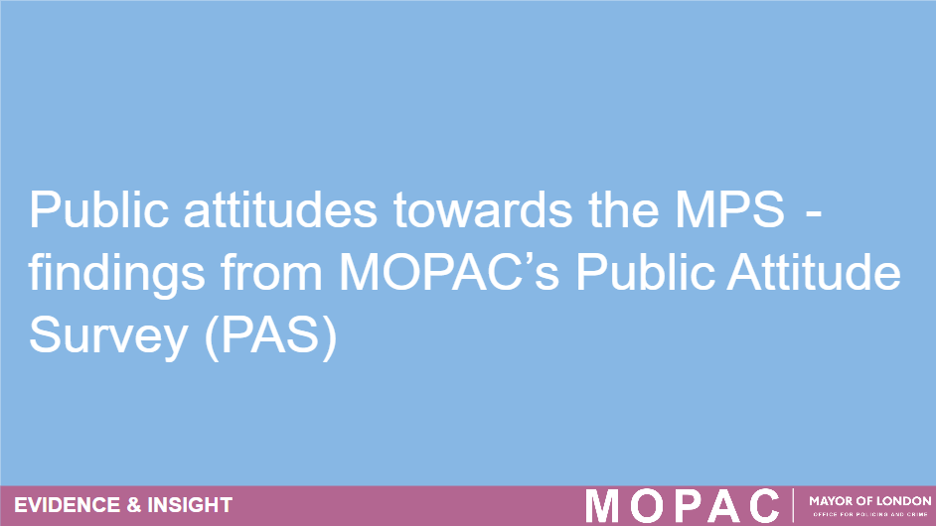  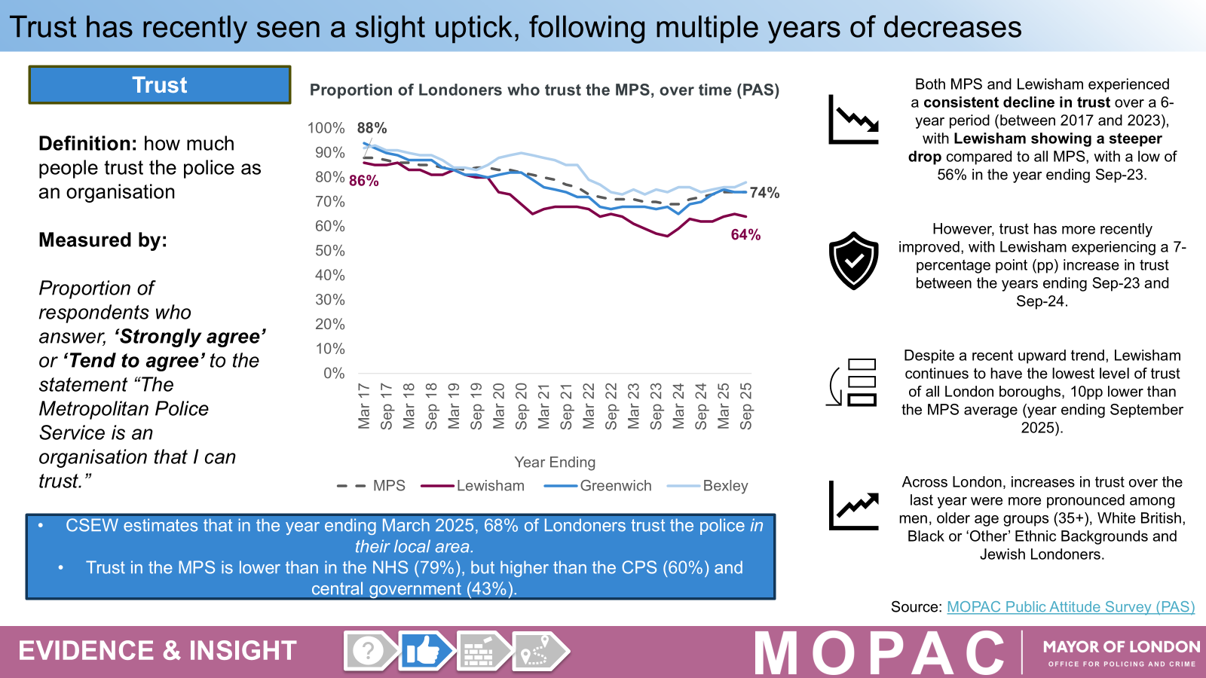  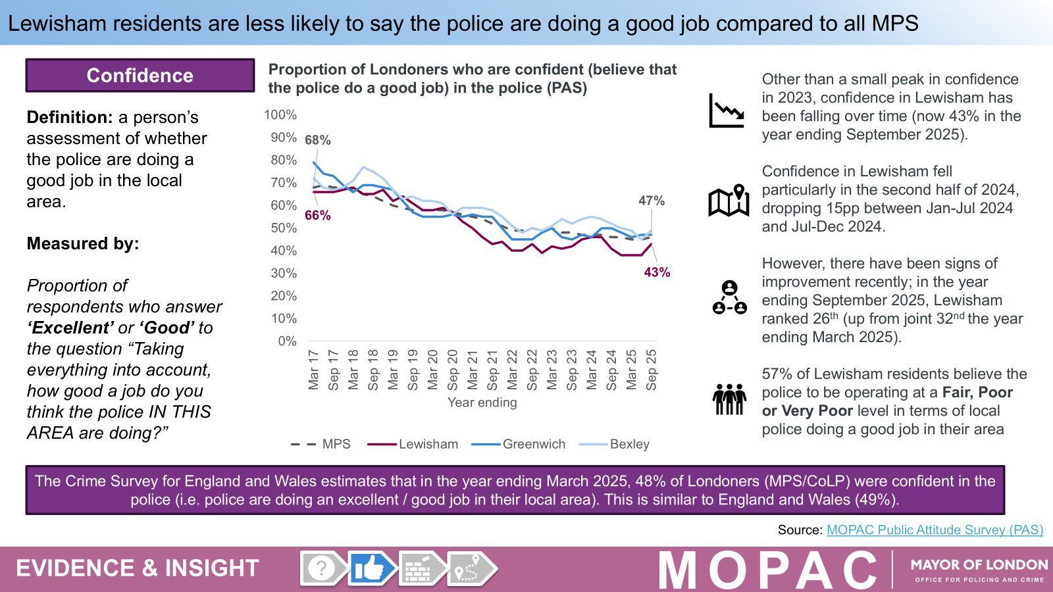  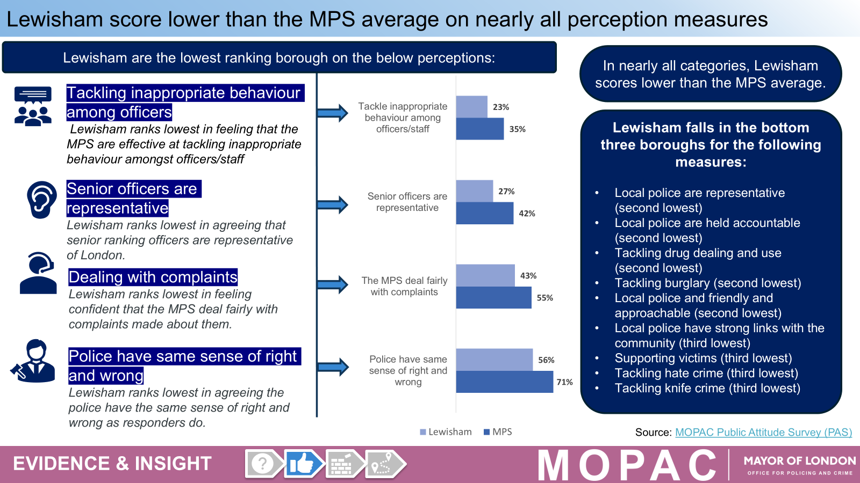  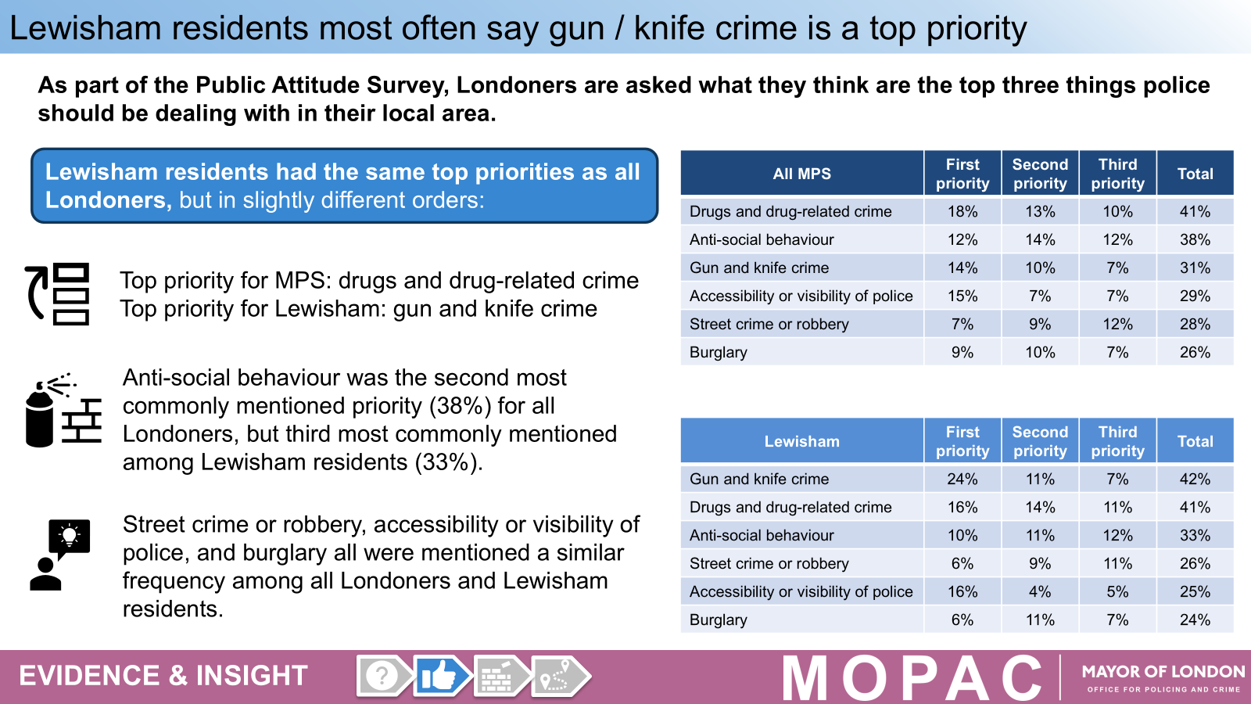  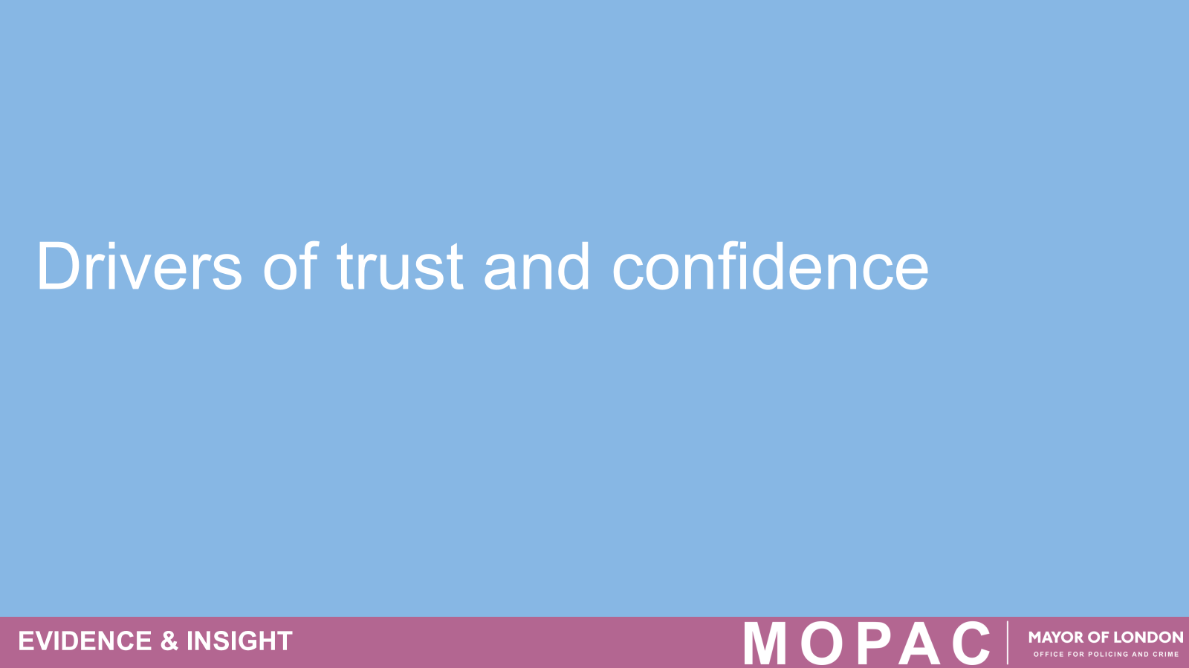  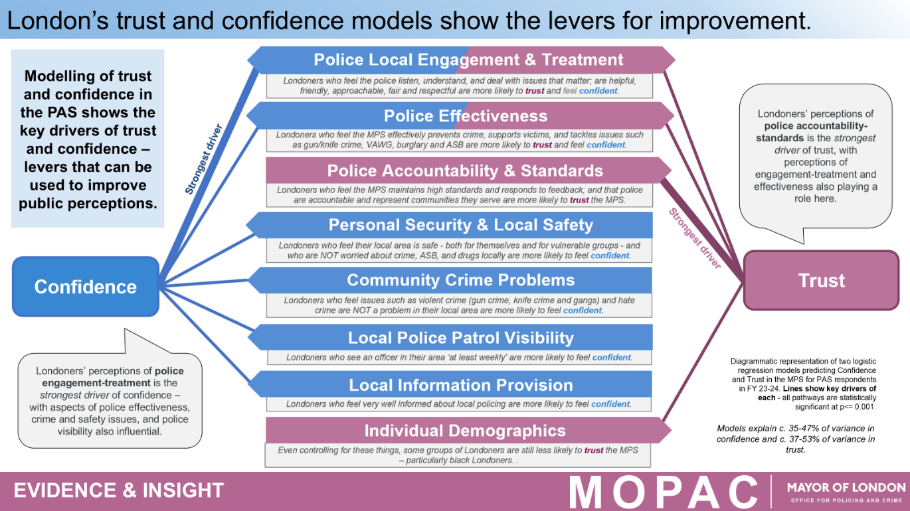  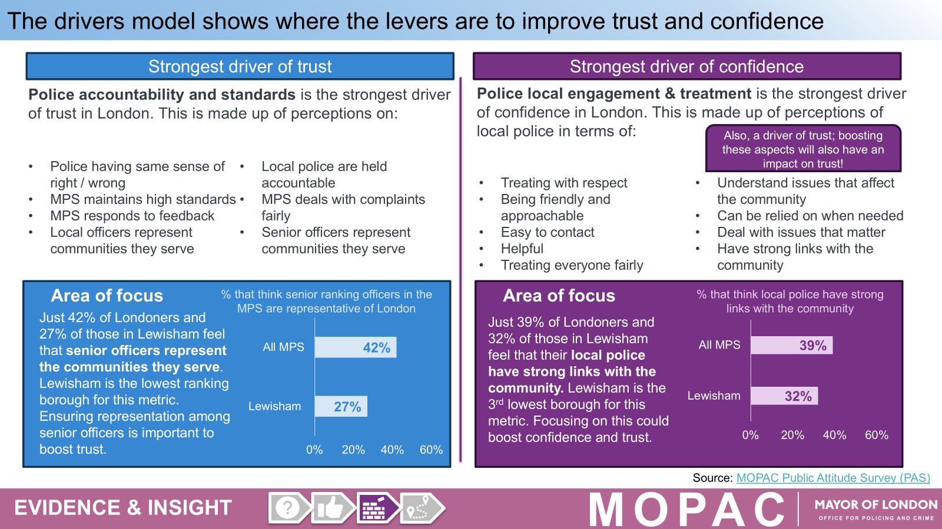  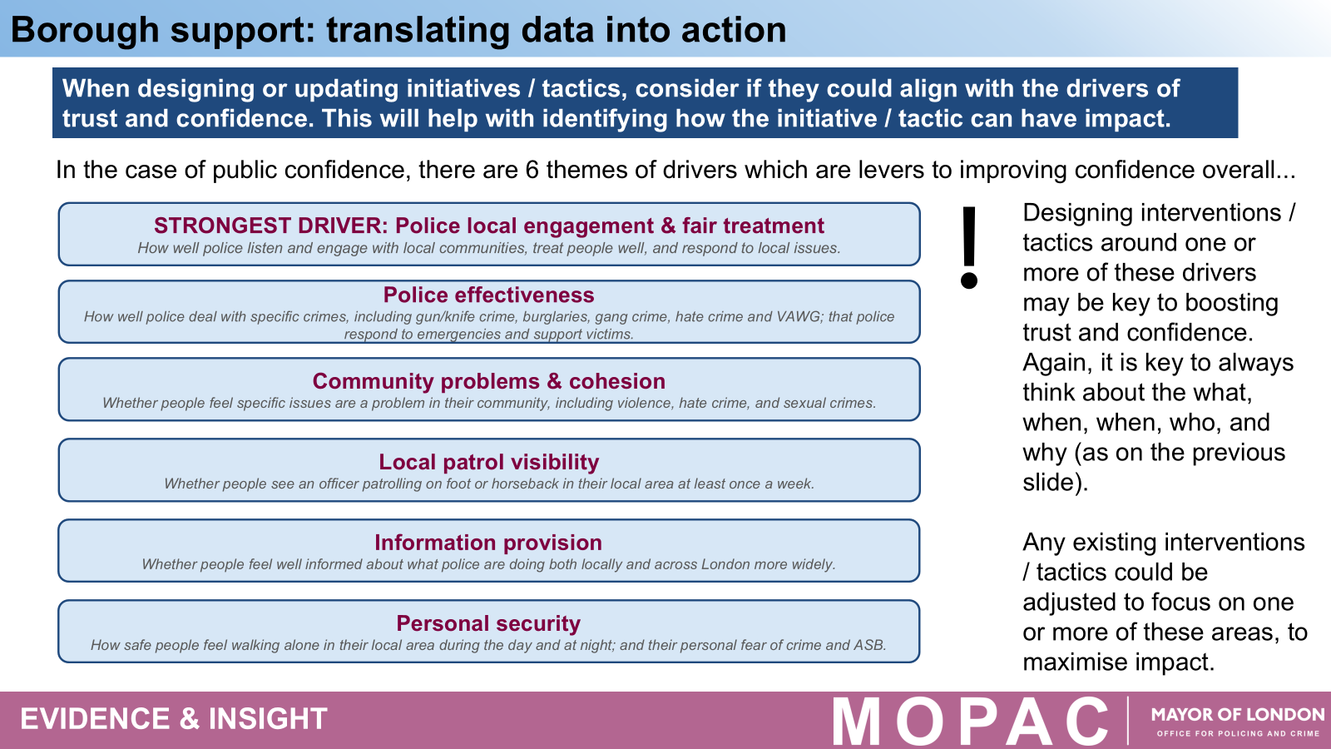  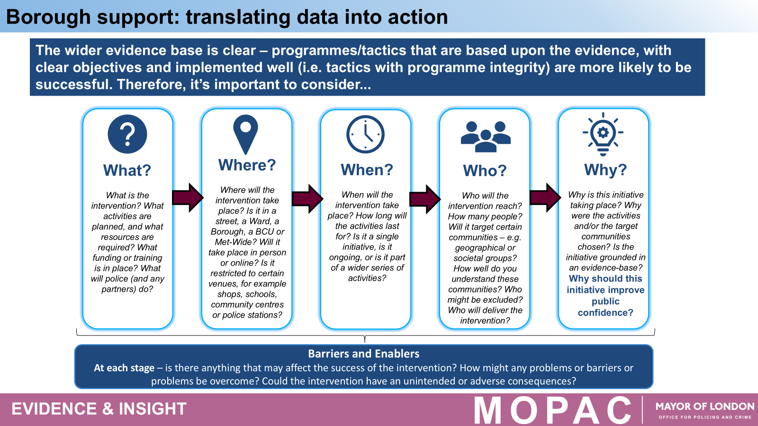  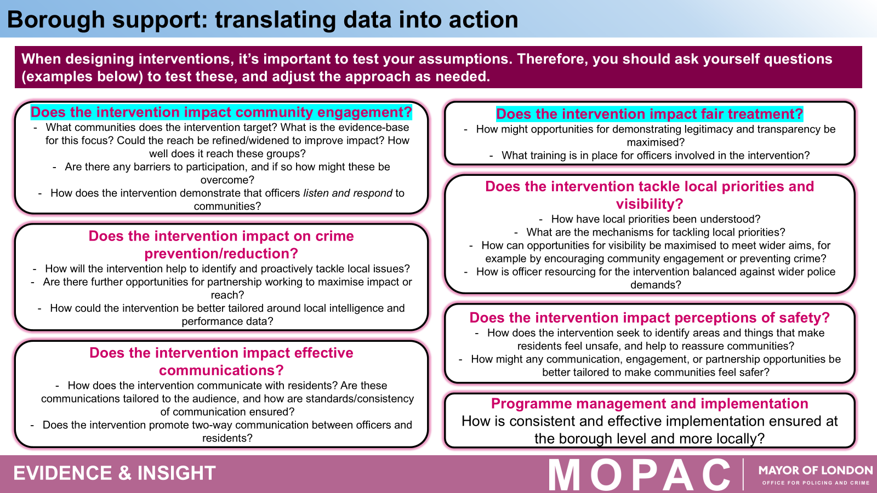  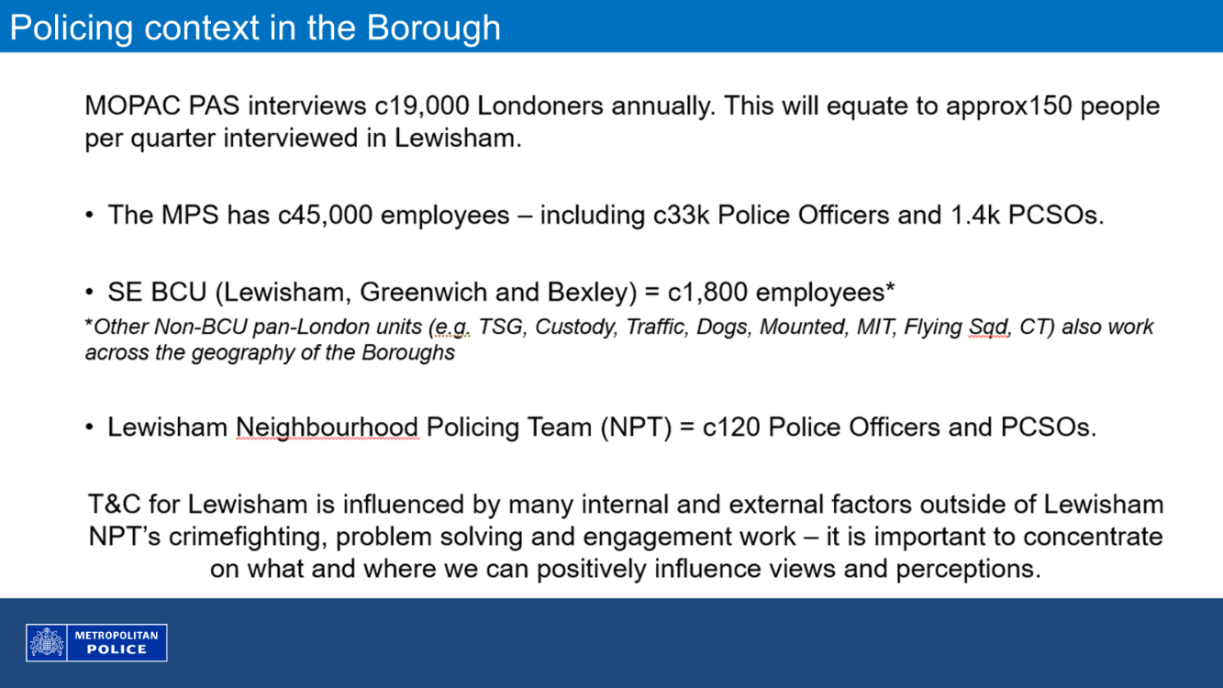  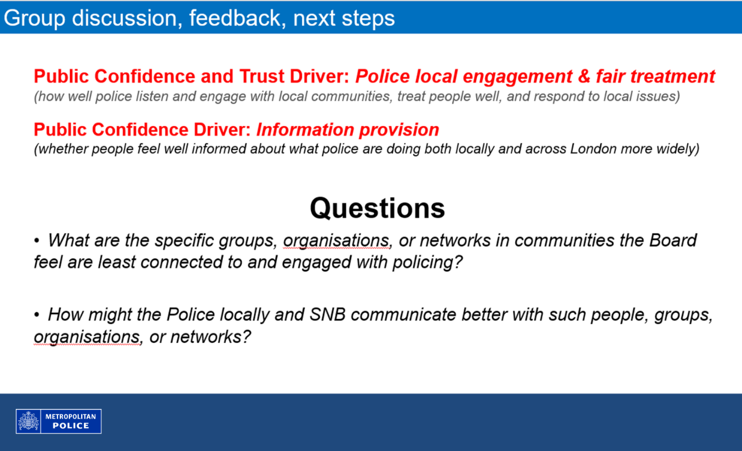  Darren Cox explained that discussions have taken place with the IAG, MOPAC and others about why Bexley consistently reports some of the highest levels of trust and confidence in the Met, while Greenwich sits around the middle and Lewisham is often among the lowest. This is despite the same officers, training and leadership working across the whole BCU.  He highlighted that this is largely about how people in Lewisham feel, rather than the service being delivered. Each borough has its own history, and in Lewisham there are long-standing experiences of trauma and harm that continue to affect trust and confidence.  He stressed the importance of doing work that genuinely resonates with residents, and of finding better ways to engage seldom-heard communities so that people can see the service in a more positive light. A trust and confidence plan is behind devised and will be shared at a future meeting.  In response to a question on why the faith officer was withdrawn when the work was appreciated by the community and needed to continue: Adrian Hanna explained that faith engagement needs to be the job of more than one officer. They need to have mechanisms in place and community-based engagement that continues at a ward level to ensure continuity and will mean that engagement won’t stop when that one dedicated officer is off sick.  Darren Cox noted that he is focusing on the areas he can directly influence, particularly the 120 officers dedicated to Lewisham Neighbourhoods. It was noted that trust relates to how people feel about policing and the Met as an organisation. Much of this is linked to wider structural changes, including those set out in the New Met for London programme, which are too extensive to cover fully in this meeting. Within the Territorial Support Group, there is also dedicated work underway to improve trust and confidence, including changes to how they operate. In relation to stop and search, it was highlighted that the focus is no longer solely on numbers or outcomes. A key measure now is the quality of the encounter and how the interaction is experienced by the individual being stopped.  The Chair allowed a number of further statements and questions to be raised, on the basis that they may not be responded due to time but would ensure they are addressed. She made the point that additional meetings need to be agreed between the public meeting, to address matters raised and associated action  NB CHERYL DO YOU HAVE THE RECORDING OF THE QUESTIONS ASKED AT THIS STAGE, SO THEY CAN BE INCLUDED.
3. | Safer Neighbourhood Board SNB Subgroup Updates  Independent Advisory Group (IAG) Update  - The group meets quarterly at Lewisham Police Station; a remote MS Teams option is available.  - Trust and Confidence  - Focus over the past year has been on helping police better address the low levels of Trust and Confidence in them within the Borough. The creation of an action plan is part of this.  - The MOPAC Public Attitude Survey (a version presented by CI Darren Cox at this meeting) has been explored and discussed with MOPAC Evidence and Insight Team members contributing. This has helped the MPS better understand conclusions and what might lead to positive change in Lewisham.  - The need to publicly demonstrate changed behaviour and specific actions is just one of the changes identified  - The recent Stop and Search analysis showing the level of disproportionality as to its use within Lewisham was also mentioned and shows that increasing the quality of S & S interactions will lead to improved Trust and Confidence.  - Taser Insight session is now April 29th  - Focus in 2026 will continue onTrust and Confidence with deeper dives into how new police recruits are taught about Lewisham’s character, as well as looking at the police complaints system. These two factors link strongly to levels of Trust and Confidence  Independent Custody Visitors (ICV) Update  - This past month we have been mourning the sudden and unexpected passing of one of our most experienced custody visitors. Sefton Campbel is known to many in Lewisham through his work providing security at Lewisham Hospital. Our memories of Sefton have been published on the National ICV Association website (https://icva.org.uk/lewisham-custody-visitors-memories-of-sefton/) as a celebration of his life in Lewisham. The article expresses the qualities Sefton brought to the ICV role as well as what he meant to so many people in and around Lewisham.  - The MPS have acknowledged that improvements are needed in their record keeping within custody to allow better understanding of how well staff look after those arrested. Areas include use of force, refusing bail and strip searches. We will be tracking how they change their systems to allow this.  - Virtual courts are slowly coming back into use increasing the strain on custody resources and increasing detention times for many of those arrested.  - Budgetary constraints also are impacting the provision of care to those arrested especially children, vulnerable adults and those who are neurodivergent. Resource shortages within the Liaison and Diversion team from the NHS who are based in custody and aim to divert certain cohorts (such as substance abusers) away from their established patterns of behaviours mean that often only remote access is possible which is not as effective.  Community Monitoring Group Update  - 2 people at a time can look through footage of body worn camera. Adrian Hanna will organise the next viewing and Royston has volunteered to be one of the participants.  - Lewisham police data on stop and search was presented by Adrian Hanna but the conversation quickly moved on to discuss the recent MOPAC/Kings College report.  The main points from this conversation included:  A consensus that the findings show us nothing new about disproportionate stop and search. It is therefore most important to agree on a way forward.  Suggestions included:  - The Met should respond to disproportional stop and search as an urgent problem.  - The findings show that the Met do not understand black people but understand white people. Thus the importance of establishing better community relations cannot be over-emphasised. Lewisham police need to change their practices. To listen to, seek to understand, and be responsive to our black communities.  - The perceived unfair use of stop and search in Lewisham is high compared to other boroughs and Lewisham police should use intelligence to stop black people and they need to give a reason for stopping a person.  - The disproportionate use of stop and search in Lewisham is not due to a few rouge officers nor is it about any exceptional officers. It is a systems problem that requires changes in procedures and practices.  • Hate Crime Working Group (HCWG)  HCWG meeting took place on 6 March, and the minutes will be made available on the SNB website. The next meeting is scheduled for May, with the date to be confirmed and advertised online  • Community Monitoring Group  • MET Command Centre 999/101 calls  A total of 33 borough residents attended the meeting on 11 March to discuss the scrutiny of 999 and 101 call handling and service delivery.  In summary, the forum reaffirmed its commitment to scrutinising operations while strengthening community relationships. Building trust remained a key theme, with a focus on better serving diverse community groups, including trans and non-binary people, disabled residents, other underrepresented groups, and young people. Increasing youth involvement was highlighted as a priority.  The forum also plans to introduce themed meetings with invited community representatives to help build trust and address specific community concerns, ensuring policing is responsive to the needs of different demographic groups. The importance of recognising that people learn and engage in different ways was also noted.  An update was provided on the implementation of video consultation services, which allow individuals to make complaints or attend appointments online if they cannot attend a police station in person. The forum reviewed early feedback on the effectiveness of these video appointments.  Due to time constraints, further discussion was deferred.  • Ward Panels  It was noted that any Lewisham resident can request to join their local ward panel. This is a key way for community members to engage with and support their neighbourhood policing teams. Residents in every borough have the same opportunity to join the ward panel where they live.  Neighbourhood Watch  These are making steady progress with business as usual.  Cheryl Spruce, national lead will hold the next Association Leads meetings on Monday 27th April from 5.30pm and Thursday 30th April from 2pm. Associations Lead 1-2-1 meeting can be booked with Cheryl by logging into the time schedule.
4. | Any Other Business  - Soho and Brixton Attacks Remembrance Event hosted by 17-24-30 on the 18th April  - For the incoming financial year, the Safer Neighbourhood Board has been allocated the same budget as last year: £23,633, which covers both administration costs and project funding.  - The funding opportunity for 2026–27 has already been launched. Information has been shared within the community and the application form is available online. Groups can apply for up to £3,000 each. Details are published on the SNB website under the Safer Neighbourhood Board 26/27 Funding Opportunity.  - UPSKILLU have been commissioned to draft the Lewisham Community Cohesion Strategy. Please complete the below survey to have your say on Community Cohesion.  https://upskillu.typeform.com/to/hOudau3b  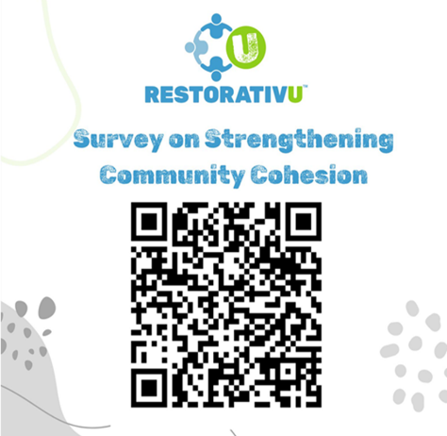  Future Public meeting dates taking place at the Civic suite with MS Teams hybrid joining option available: 16th June, 22nd September and 8th December 2026

